**\*\*PLEASE INSERT YOUR COMPANY LETTERHEAD WITH ABN\*\***

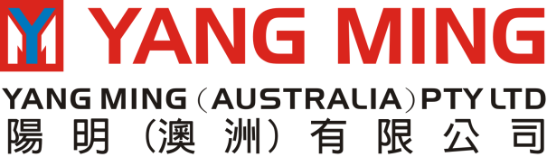

**Level 13, 60 Albert Road South Melbourne VIC 3205 - TEL: 1300 711 501 FAX: (03) 8646 6750**

**ELECTRONIC IMPORT DELIVERY ORDERS (EIDO)**

**CONSIGNEE'S DETAILS:**

Name of Organization: ……………………………………………………………

Contact Person: …………………………………………………………..

Email Address: ……………………………………………………………

**Should you require the EIDO issued to a third party please fill the details below:**

We …………………………….........................hereby authorize our agents Australian Managed Servicing Pty Ltd to receive (on our behalf) from you Electronic Delivery orders on the following email address/es:

|  |  |
| --- | --- |
| **Discharge Port** | **EIDO Receiver email address** |
| AUSYD | transport@ausmanagementservice.com |
| AUMEL | transport@ausmanagementservice.com |
| AUBNE | transport@ausmanagementservice.com |
| AUFRE | transport@ausmanagementservice.com |
| AUADL | transport@ausmanagementservice.com |
| Tradegate ID# |  |

We acknowledge that it is our responsibility to inform Yang Ming (Australia) Pty Ltd of any changes to the above.

We also confirm that we do not hold Yang Ming (Australia) Pty Ltd liable for any matters that may arise as a result of releasing EIDO to the above nominated party.

CONSIGNEE SIGNATURE: ……………………………………….............................

COMPANY STAMP

Name of authorized signatory: ………………………………………………………………

Date: ..................................…………………………………

Please be informed that in the case of Original Bills of Lading / Sea waybills / Express release – the EIDO will only be released under our existing release policy.

*EFT payments* – payment must be clearly identifiable and receipt of funds confirmed by our bank prior EIDO release. Yang Ming (Australia) Pty Ltd will **NOT** accept responsibility for any banks delays to inform us of the receipt of payments.

In order to obtain prompt release of cargo – please ensure our invoice/bill number is used when providing a (payee) reference number during transaction process. Please also ensure any (EFT) EIDO requests made via email include relevant bill of lading number/s, and include a copy of the bank remittance. Please refer to applicable tax invoice for account details.

Signature on this document is acceptance of our terms & conditions and also acknowledgment that any Equipment Detention/Demurrage invoiced due to late return of containers and/or costs arising out of Damage or Loss of containers will be paid by you to Yang Ming (Australia) Pty Ltd.

In regard to where the empty containers are to be returned, this information will be listed on the EIDO. It will be the responsibility of the consignee and/or the customs broker to on forward a printed copy of the email EIDO to the transport operator. Please note the depots will **NOT** accept any empty containers without a copy of the printed email EIDO.

Should you need any further clarification please contact our Imports department on Email: **csimp@au.yangming.com**